Barry Haygood

12/21/2019

Summary Findings for Matplotlib Homework:

The study consisted of examining the effect of anti-cancer drugs on tumor growth and mortality with mice. The following data was collected over a 45 day period:

1. Mouse survival
2. Tumor growth (volume) change
3. Number of metastatic sites

Observation 1:

The drugs Capomulin and Ramicane had a dramatic effect on reduction of tumor volume and lower overall number of metastatic sites. The other drugs had an effect similar to placebo. See Figure 1. Tumor Response to Treatment and Figure 2. Metastatic Spread During Treatment.

Figure 1. Tumor Response to Treatment

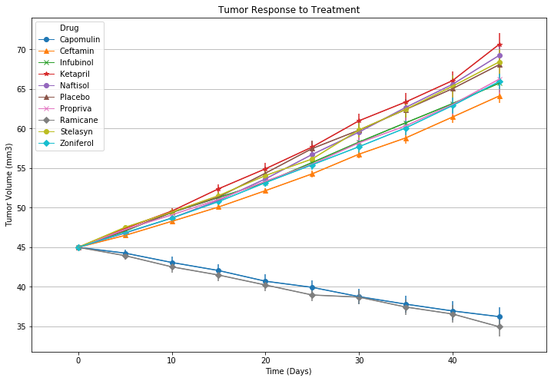

Figure 2. Metastatic Spread During Treatment.

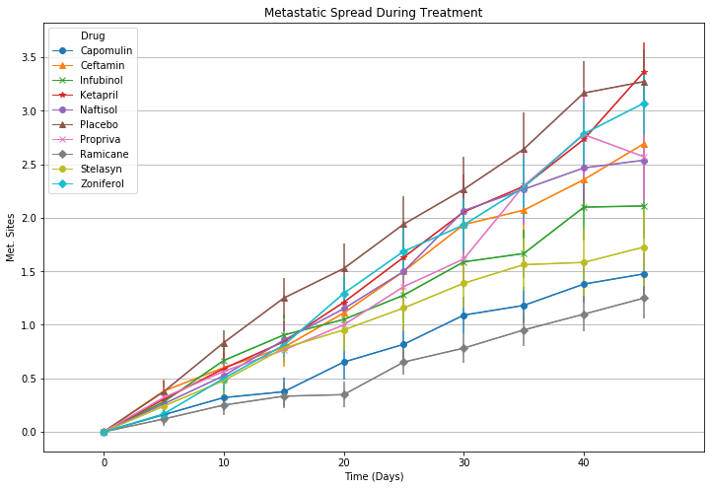

2.) Observation 2:

Mouse mortality was positively affected by the reduction in tumor volume and metastasis for Capomulin and Ramicane. Figure 3 demonstrates that there does not appear to be increased mortality with the drugs (no ill side effects). Both drugs demonstrate approximately a 1.8X increase in survivability.

Figure 3. Survival During Treatment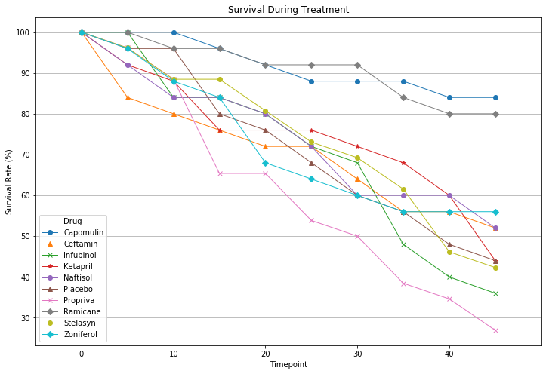

Observation 3:

The small degree of error demonstrated in Figure 1 gives confidence in the results in tumor volume reduction. Overall tumor reduction is summarized in Figure 4.

Figure 4. Tumor Change over 45 Day Treatment

